The Bishop in Europe:
The Right Reverend Dr. Robert Innes

10 October 2020

Dear Brothers and Sisters in Christ,

Bishop’s Advent Appeal 2020

Covid-19 Support to the Anglican Communion

Last week, we witnessed a deeply sobering point in our global struggle against Covid-19: over 1 million people worldwide have now died from the virus. We know and see the impacts of Covid-19 in our own communities here in Europe, and the stresses and strains it brings for us all in our daily lives. We see too, numbers of infections and deaths increasing once more among us, across the Diocese in Europe.

In Morocco (within our own Diocese) there have now been over 140,000 confirmed cases, and nearly 2,500 deaths. In South Africa, despite introducing one of the severest lockdowns in the world, over 685,000 cases have been recorded. In some areas of Africa, Covid-19 is exacerbating both ongoing violence, conflict and bloodshed and existing health crises, like tuberculosis. Lack of testing and data issues mean the real numbers in Africa may actually be far higher than those recorded. John Nkengasong from the Africa Centres for Disease Control told the BBC yesterday: “I don’t think we are over the first wave yet, we have not yet hit the bottom at all.”

In response to emergency needs right across the Communion, you may have seen that the Archbishop of Canterbury launched a Covid-19 “Together in Unity” Appeal. I am delighted that his Appeal has already raised over £100,000. My Advent Appeal this year is to urge your support for the work the Anglican Communion Fund is doing to alleviate the ravaging impact of Covid-19 in the poorest parts of the world. The Anglican Communion Fund (ACF) is making a difference on the ground to people who are suffering every day, the human cost of this pandemic.

Behind the statistics are human life stories of deprivation from lack of food, access to basic hygiene and sanitation facilities, and worsening economic hardship in the poorest communities for those unable to work. Below and attached are illustrated examples from ACF-supported projects in Sudan and Mexico. Where you have relationships with churches across the Communion, you will know of their situations, with first-hand reasons to support an Appeal to help those who have already lost so much and have least.
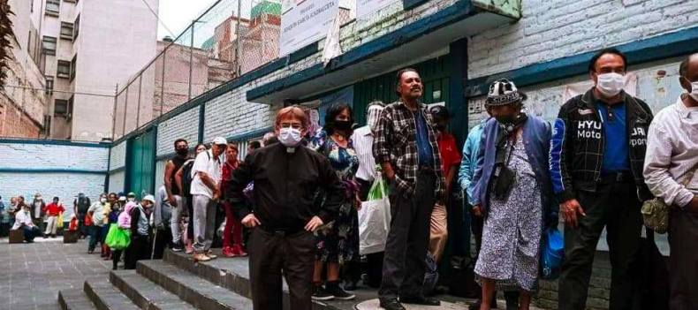

People queue for hot meals and food and essential supplies in Mexico City. Photo (The Anglican Church of Mexico provided by ACF)

I am delighted that, with your help, the diocese raised nearly £15,500 for my Advent Appeal 2019 to promote the empowerment of women in the Anglican Communion. I should add that ACF also provides key support to our own work representing the Anglican Communion in the European Institutions, on issues such as migration and refugees, human rights, freedom of expression and belief, and domestic violence against women.

I attach some resources you may wish to draw on for your chaplaincy bulletins and newsletters on ACF’s Covid-19 projects. Among these you will see that Bishop Moses Zungo from Maridi Diocese in South Sudan expresses his gratitude for ACF’s support, saying, “You held our hand during our most trying moments.” I hope we in our diocese can help with an outstretched hand to brothers and sisters in the Anglican Communion who are suffering so deeply right now from the impact of Covid-19, by supporting the work on the ground by the ACF.

Please give as generously as you can to this Advent Appeal. You can find details of how you can donate attached.

With every blessing,

+Robert Gibraltar in Europe

Some resources for your chaplaincy bulletins and newsletters:

Under 50 words

The COVID-19 pandemic has hurt communities throughout the world. Many communities are not equipped with even the most basic of hygiene and sanitation facilities, and lockdown measures have increased economic hardship in the poorest communities with people unable to work.

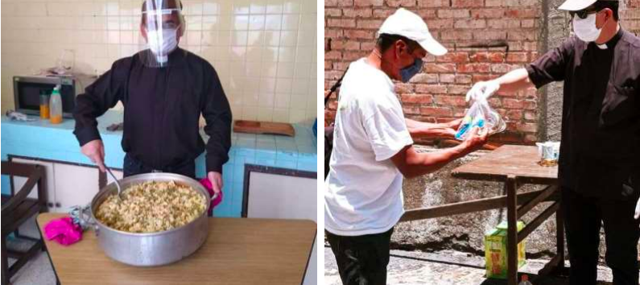

A grant from the ACF supported the provision of food, drinking water, hygiene equipment and medicines in Mexico in the wake of COVID-19. Photos (The Anglican Church of Mexico provided by ACF).

Under 200 words

The COVID-19 pandemic has hurt communities throughout the world. Many communities are not equipped with even the most basic of hygiene and sanitation facilities, and lockdown measures have increased economic hardship in the poorest communities with people unable to work. We are raising funds to support virus prevention and emergency relief for vulnerable communities throughout our Anglican family.
The Anglican Communion Fund (ACF) has already begun responding to COVID related needs, allocating over £180,000 across 21 provinces of the Communion. The ACF is supporting the Church in its ministry, providing food relief to the vulnerable, communicating ways of staying safe from the virus, and providing handwashing facilities and PPE.
In the South Sudanese Diocese of Maridi, an ACF grant provided food items, soaps and seeds to over 200 pastors and lay-readers and provided bicycles and hand microphones for pastors to carry prevention messages into remote areas. Speaking of the support, Bishop Moses Zungo said, “You held our hand during our most trying moments.”

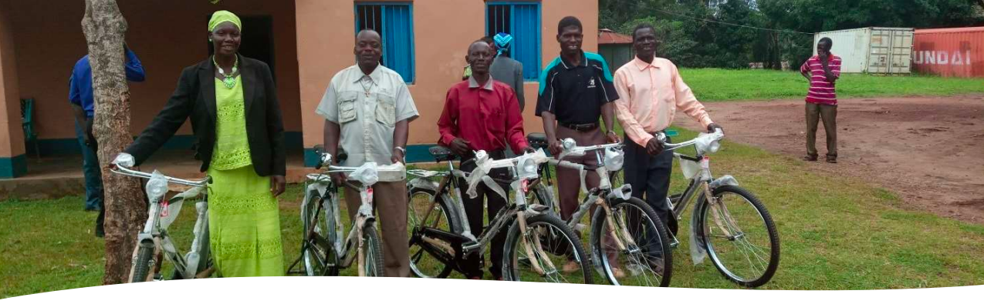

(Photo: Maridi Diocese, South Sudan, provided by ACF)

**

Video message

This video introduces the “Together in Unity” appeal from Archbishop Justin Welby featuring images of the impact of COVID-19 across the Anglicans Communion and the testimonies of two Anglican primates.

https://youtu.be/5U2i_bMCneM

***

How you can donate to the Bishop in Europe’s Advent Appeal 2020:

By cheque:

“Advent Appeal 2020”.
Diocese in Europe Board of Finance Office
14, Tufton St
London SW1P 3QZ

By bank transfer:

Account number: 40317039
Sort code: 20-06-13
IBAN: GB16 BUKB 2006 1340 3170 39
Swiftbic: BUKBGB22

On the Diocese in Europe Just Giving page:

https://www.justgiving.com/diocese-ineurope

